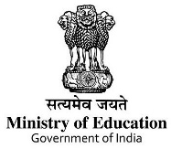 | Six Days Faculty Development Programme on  Mentoring Institutional Social Responsibility and Facilitation for Community Engagement  12-17September 2022 | 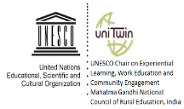
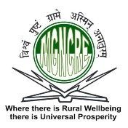 |  | 

Organized by
Mahatma Gandhi National Council of Rural Education
Department of Higher Education, Ministry of Education, Government of India
Hyderabad
In collaboration with

Wardha Samaj Karya Sansthan

Mahatma Gandhi Antarrashtriya Hindi Vishwavidyalaya, Wardha

ApplicationForm
Name of the participant (In Block Letters):

Designation: __ _ _ Age: ___ _Years, Gender: M/F

Name of the Institution

Address for Correspondence

__ _ _ _ _ _

Contact Details :( Mobile) ___ _ _Email Id: _ _

Need of Accommodation: Yes/No

Date of Arrival to Wardha

Date of Departure from Wardha: _ _ _ _ _

Signature
Forwarding from the Institute

The above-mentioned faculty is nominated from the Institute__
__ _ _ _ _for attending said faculty development program on said period.

Date:
Signature of the Head of Institute
Seal

